# Message class

## Navigate to SE93.

## Create a message class.

Figure Creating the message class.

## Navigate to Messages.

Save it in the package.

## Create the message.

Figure Create the message.

Save it.

## Using it in the report.

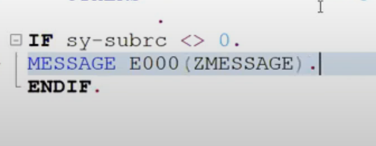

Message class

Message number

Message type

Key word